***Name: Aarya Tiwari***

***Batch : B2***

***Roll no. – 16010421119***

**Experiment 1**

**Some good principles towards a good UI/UX design**

1. **Keep It Simple**

People spend less than 15 seconds on a website. Keeping them focused on your brand’s message requires a design that is clear and simple. This can be achieved by following the “less is more” concept and avoiding a busy, cluttered design.

Users are more likely to find the key messaging on your website if they have less content to scroll through and fewer options to choose from. Minimizing the options on your site will increase the likelihood that readers will take the action your brand seeks, such as leading them through a sales conversion funnel. Imagine the best grocery store experience where everything along the way is exactly where you need it!

1. **Use Consistency**

Readers will find it easier to scroll through your site if you use consistency in your design. This applies to your colors, fonts, buttons, layout structure, photograph style, and more. The point is to make these design components familiar to your users, which helps make things more intuitive and predictable. And people do like predictability!

Beyond the internal consistency, website visitors also like to make connections with design conventions used across the web. The location of navigation buttons, the option to “read more” on content, and the use of autofill on a web form are all common design features across the digital landscape.

1. **Be Intentional**

Choose the elements of your design with a purpose in mind. The colors, visual elements, and layout you select should all be intentional and not just because they look good.

Looks aren’t everything! Design is more about how something works than how it looks. It’s about both form and function.

Here are some guidelines for designing with intent:

* Choose a colour because it’s part of the brand identity guide or because it evokes the desired emotion.
* Choose a font because it shows personality and allows the user to more easily read your content.
* Choose a visual element that helps users accomplish a task on the site.
* Choose a layout that showcases the most important parts of your design and that improves site navigation.

1. **User control**

Another important element of UX design principles centres on giving the user the right amount of control over how they interact with a product.

“Users often perform actions by mistake. They need a clearly marked ‘emergency exit’ to leave the unwanted action without having to go through an extended process.”

So, the principle of user control is all about helping users to correct or reverse errors without throwing the entire user experience into disarray. You can build user control and freedom into your product by incorporating “Undo” and “Redo” functionality, providing “Cancel” buttons and clearly labelling alternative actions and routes the user can take if they want to revert a particular action.

1. **Accessibility**

The fifth of the UX design principles, Accessibility, is critical to good UX and all UX designers have a responsibility to understand what it means and to factor it into the design process.

Accessibility is about ensuring your product or service is accessible to and usable for as many people as possible. It includes catering to the needs of people with disabilities, as well as understanding how different environments or situational factors might impact the user experience.

One example of designing for accessibility could be to use high colour contrast to ensure that text is legible for users with visual impairments. For real-world examples of accessible design in action, check out these websites which have nailed the accessible design principle.

1. **Set Expectations...**

Along the lines of using consistency to create predictability, users also want their expectations for browsing your website to be met. They want to understand what will happen if they take an action on your platform. Tell users what the buttons on your website are intended to do. If the button will sign them up for your newsletter, add appropriate text on the button—“Sign Up Now” or “Join Our Email List”—that tells them exactly what will happen if they submit their email address.

Another feature readers will appreciate is an animated loading graphic. These “loaders” will let them know that the page is not frozen if there is a wait time while something loads.

Meeting your users’ expectations requires some design elements that may be obvious. For example, give commonly used names to the headers on the navigation menu. This will reduce any potential frustration readers may have while navigating and becoming familiar with a new platform.

1. **Use Responsive Design**

Mobile usage has surpassed desktop usage and each year its share of online traffic rises. That’s why you need to use a responsive design on your site so that users can easily read and navigate it on any device.

A website design that isn’t mobile responsive may, for example, force users to enlarge the text on the screen to make it legible. Most often, readers who have to adjust the site on their cell phone to work around your non-responsive design will simply give up and leave your site.

Providing a responsive website doesn’t only enhance the user experience. In fact, Google awards higher rankings to sites that are mobile-friendly, which translates into higher traffic on your site. (There’s that SEO, again!) Responsive websites load more quickly, look great on every screen, and are easier to update.

It’s critical to make a positive first impression on users coming to your site from mobile devices. If you don’t, you might lose them to competitors’ more mobile-responsive sites.

AltaFoodcraft, a company that provides office coffee and refreshment services, has a fully responsive website. If you look at the site on a cellphone, the home page is easy to read and navigate because it has been optimized with a responsive design.

1. **Plan For the Future**

While building the website or mobile app that you need now, take into account that your site will likely change in the future. That is why you should create your site on a framework that’s flexible enough to allow you to adapt, change and expand as your business grows.

Choose your tools wisely so that you will not end up with a site with components that cannot be updated. A case in point: Adobe Flash was once a standard software platform that was used for the production of animation, apps, and mobile games. Yet Adobe has announced it will no longer update or maintain Flash after 2020, which means web developers will have to switch to alternate solutions if they haven’t already.

Another way to future proof your website is to monitor how your website performs. By using solid tracking and reporting from the start, you will have the data you need to guide future decisions.

1. **A Hospitable Site Is Accessible and Inclusive**

How will users who are colourblind or have a hearing impairment experience your site? Creating a website that is disability-friendly might not be something you “see” right from the start—unless you happen to be someone who needs to navigate the platform using accommodations.

Try using a screen reader, assistive touch, or a colorblind web page filter and you’ll have an entirely different perspective on whether your site is truly accessible. The first step in making your site available to all users is to determine whether your site’s design creates obstacles for users with disabilities.

Here are a few tips for providing an accessible site:

* Choose black text on a white background instead of colored text.
* Use subtitles on videos posted on the site.
* Use descriptive alt tags on images so screen readers can describe them for the user.
* Create larger buttons for people with fine motor skill difficulties (or those of us prone to “fat-finger” syndrome).
* You can test your site’s accessibility at WebAccessibility.com to see where it ranks. After reviewing the results, make the recommended modifications to ensure your website can be used by anyone—no matter how they view it.

1. **Recognition Rather than Recall**

It is easier to recognize things than to recall them. Your design should keep options, actions, etc visible to reduce the load on the users’ memory. Users should not have to remember information from one display to another. A website that keeps requesting for your username and password every time you use it can be frustrating. Try searching for a video on Youtube, notice how the several options are listed before you are done typing. Now, imagine if you had to remember the title of a video on Youtube before you can find it. Frustrating, right?

**Some websites which have a great UI/UX**

1. **Dropbox (Best Scenario)**

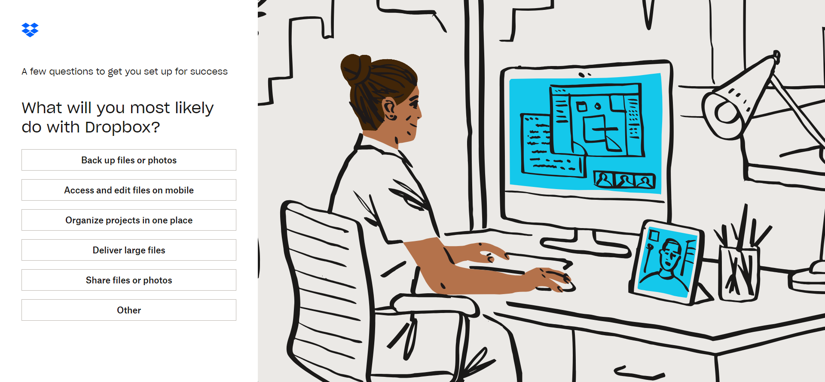

* Dropbox has one of the most easily understandable interfaces by far. Having a folder and file organizational structure is easily recognizable to, you know, anyone who’s ever used a computer before. In terms of learnability, there isn’t much that the average user won’t already know how to do from the start.
* Dropbox’s friendly personality, created by light-hearted illustrations, helps the user feel comfortable when using the product. This addition to the interface makes the product feel like an old friend, ready to help users complete their file-sharing tasks.
* There’s so much attention to detail, with sequenced color palettes and animated icons, and wonderful illustration that is coordinated with all the other wonderful illustrations—it manages to come across as experimental, creative, and consistent. That’s quite an achievement! Check it out!

1. **Headspace (Moderate Scenario)**

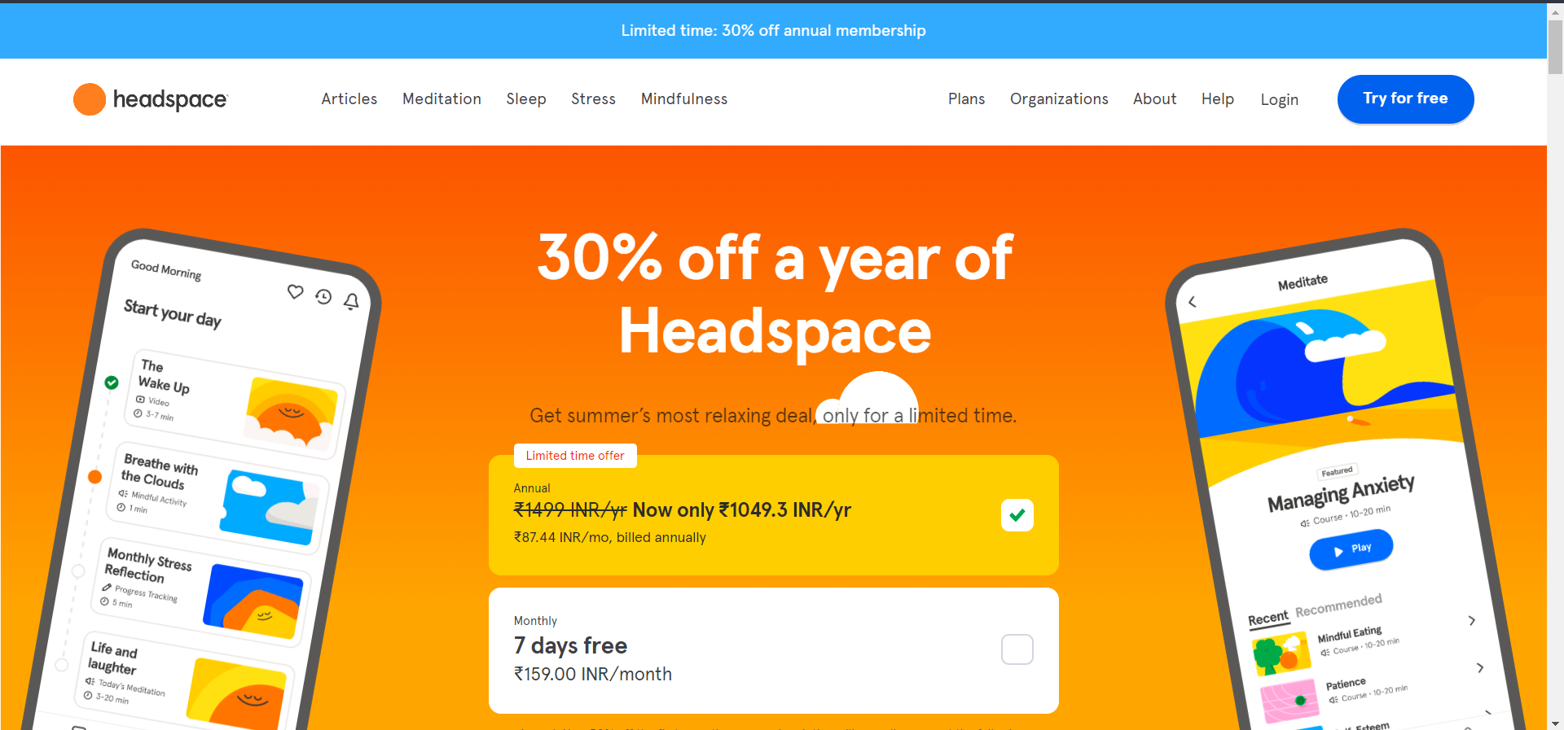

* In 2023 we are all more open to diversity, and some mobile apps seem to be adapted to it, too.
* One of the most famous well-being and mindfulness apps, Headspace, wins my heart with its inclusive UI design with accessibility tools.
* You can also change the font and the colour of the texts within the app, which is a big plus.
* But more importantly, Headspace integrates VUI (voice user interface) into its design. It is basically a speech-recognition interface to respond to human voice and turn voice into text.

1. **The Big Ugly Website (Worst Case)**

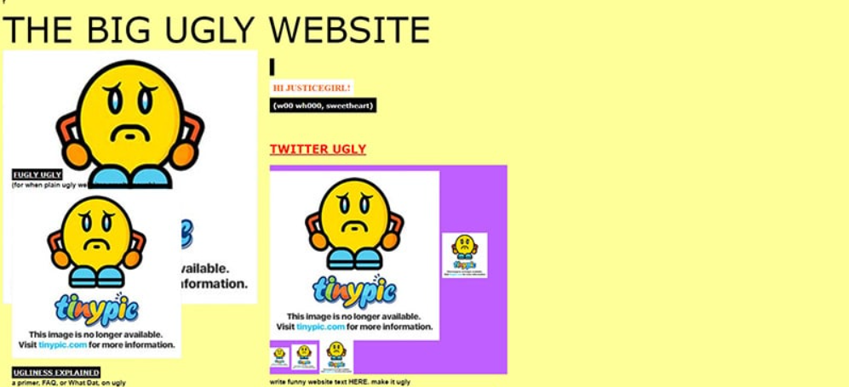

* Designers deliberately created the Big Ugly Website to show all the horrors of obsolete design and lame websites.
* This is a powerful example for those who believe that the rest of the website is too ugly and inconvenient to be included in this summary.
* There is no navigation here, but there are large and useful animations, unappealing fonts, underlined text, and banners everywhere. To make a long story short, this website is a shambles.

|  |  |  |  |
| --- | --- | --- | --- |
| **Aspect** | **Good Design**  **(Dropbox)** | **Moderate Design**  **(Headspace)** | **Bad Design**  **(the Big Ugly Website)** |
| Visual Consistency | Consistent use of colors, fonts, and visual elements | Some level of consistency, but occasional mismatches | Inconsistent elements leading to a chaotic appearance |
| User-Friendly | Intuitive layout and navigation | Navigation may require some effort | Confusing layout and difficult navigation |
| Clear Information | Information presented clearly and logically | Information might be cluttered | Unclear and disorganized information |
| Readability | Proper contrast, font size, and spacing | Readability could be improved | Poor contrast and small fonts |
| Mobile Responsiveness | Responsive design for various devices | Some responsiveness, but not fully optimized | Not optimized for mobile devices, leading to usability issues |
| Accessibility | Adheres to accessibility guidelines | Partial accessibility support | Neglects accessibility, making it hard for some users |
| Performance | Fast loading times and smooth interactions | Acceptable performance, occasional lag | Slow loading, frequent crashes |
| Aesthetics | Pleasing visual aesthetics consistent with the brand | Average aesthetics, lacking uniqueness | Unappealing and visually unappealing |
| Error Handling | Clear error messages and helpful guidance | Some error handling but may be unclear or generic | Unclear error messages, leaving users confused |
| Consistent Feedback | Provides appropriate feedback for user actions | Feedback might be delayed or inconsistent | Lack of feedback or feedback not relevant to user actions |
| Alignment with Goals | Design supports user goals and tasks effectively | Design partially supports user goals | Design hinders users from achieving their goals |